CRUFTS 1952 to 1978 – Lists of Qualified (where available) plus Winners Compiled by Shirley Budgen 2018
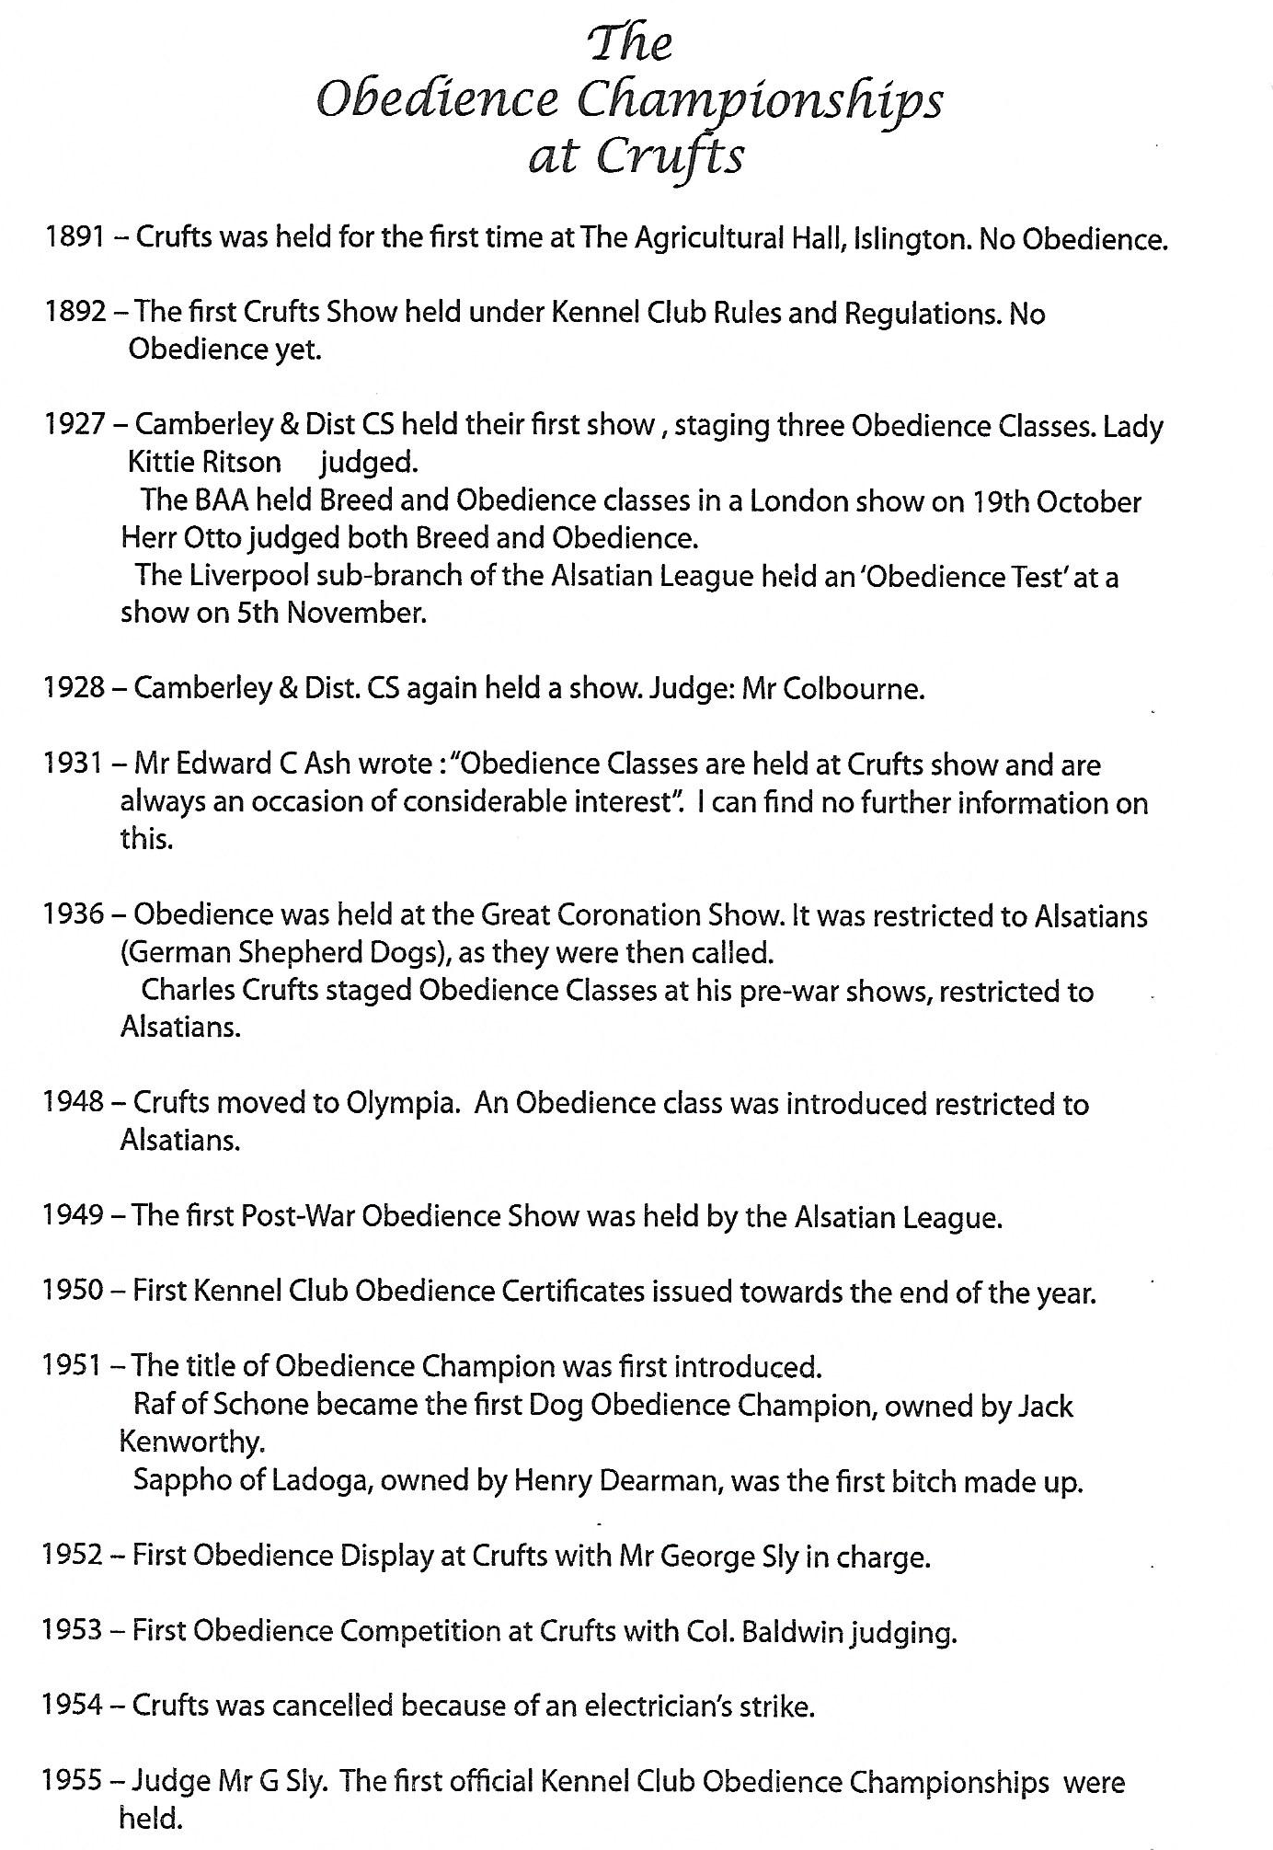
1952 – This was a ‘Crufts Obedience Display’
Judge: George Sly – Winner: Siegfried Of Jotunheim - GSD – Mr D Hudson
1953 – Judge: Lt Col J Y Baldwin DSO
1954 – Crufts CANCELLED due to an electrician’s strike
1955 – The first official KC Obedience Championships where you had to win a CC to compete
Judge: Mr G Sly
Dog: Ob Ch Sheperdon Spun Gold – GSD – Miss H D Homan
Bitch: Ob Ch Della Of Gipton – GSD – Mr W J Spencer
No entrant list available
1956 – Judge: Mr R M Montgomery
Dog: Ob Ch Dash – BC – Mr Bill Shackleton
Bitch: WT Ch & Ob Ch Amaryllis Of Helmdon – GSD - Mrs Daphne Foreman
No entrant list available
1957 – Judge: Mr K Butler
Dog: Ob Ch Dash – BC – Mr Bill Shackleton
Bitch: Ob Ch Copyright Of Rozavel – GSD – Mrs Vera Jones
No entrant list available
1958 – Judge: Mrs Mary Porterfield
Dog: Ob Ch Amphion Of Plaermo – GSD – Mr Frank Hawes
Bitch: Ob Ch Megan of Monksmead – BC – Mrs Muriel Pearce
No entrant list available
1959 - Judge: Mrs B Langley
Dog: Ob Ch Castlenau Pizzicato Cdex, Udex, Wdex – GR - Mrs K Needs
Bitch: Raffina of Schone – GSD – Mr W S Randall
No entrant list available
1960 – Judge: Mr D Churchman
Dog: Iliad Of Tollhurst – GSD – Mr B Davis
Bitch: Ob Ch Zena Cdex, Udex – BC – Mr Bill Shackleton
No entrant list available
1961 – Judge: Mrs Audrey Montgomery
Dog: Ob Ch Black Gold Cdex, Udex – GSD – Mr Jerry Coult
Bitch: Ob Ch Zena Cdex, Udex – BC – Mr Bill Shackleton
No entrant list available
1962 – Judge: Mr F W Ratcliffe
Dog: Ob Ch Glyn Of Rigi – BC – Miss H D Homan
Bitch: Ob Ch Megan of Monksmead – BC – Mrs Muriel Pearce
No entrant list available
1963 – Judge: Mr N Haydock
Dog: Ob Ch Glyn Of Rigi – BC – Miss H D Homan
Bitches: Amanda Of Jumaral – GSD – Miss June Bate
No entrant list available
1964 – Judge: Mr L Pagilero OBE FCIS
Dog: Holmflow Rebel – GSD – Mr K F Smith
Bitch: Ob Ch Megan of Monksmead – BC – Mrs Muriel Pearce
No entrant list available

1965 – Judge: Mr Bill Spencer (judges dog was qualified but did not run)
Dog: Ricky Royalist – GSD – Mr Ron Edwards
Bitch: WT Ch Hankley Andromeda – GSD – Mrs Daphne Foreman
1966 - Judge: Mr Vic Butler
Dog: Ob Ch Flak Of Ardgye – GSD
Bitch: Ob Ch Megan of Monksmead – BC – Mrs Muriel Pearce

1967 – Judge: Mrs B V Hill
Dog: Dirk of Twistwood Cdex – XB – Mrs J Makinson
Bitch: Ob Ch She’s Tiffin – WSD – Mrs J M Warren (spelt several ways: report: Warrant & entrant list Wareen)
1968 – Judge: Mr Jack Kenworthy
Dog: Tam II – BC – Mrs J Faulconbridge
Bitch: Inge Shah Of Westondale – GSD – Mr J M Reeves
1969 – Judge: Mrs Muriel Pearce
Dog: Ob Ch Blaze of Sealight – WSD - Mrs B Bellamy
Bitch: Ob Ch Moss – BC – Mrs W Sivyer

1970 – Judge: Mrs Vera Jones
Dog: Ob Ch Micklyn Shandy – XB – Mrs J M McMillan
Bitch: Merry – BC – Mrs H Holmes

1971 – Judge: Mr W Shackleton
Dog: Ob Ch Jaff – BC – Mr Frank Smith
Bitch: Shepdine Bonnie Of Sealight – WSD – Mr Brian G Jordan

1972 – Judge: Mr Len Pearce
Dog: Tevis Border Brett Cdex – WSD – Mr F Hamilton
Bitch: Kinder Syde Raven – GSD – Mrs B Collins

1973 – Judge: Mr Norman Braithwaite
Dog: Ob Ch Golden Gift Cdex – GR – Mr J W Burdett
Bitch: Ob Ch Daintree Debutante Of Hallohas – GSD – Mrs S Snook
1974 – Judge: Mr Norman Hills
Dog: Moss Of Thornymoor – BC – Mr F D Herman
Bitch: Ob Ch Mischief Of Tamerrye – BC – Miss I Standfield
1975 – Judge: Mrs Patricia Haydock
Dog: Ob Ch Stillmoor Jamie of Hurstview – BC – Mrs P A Lister
Bitch: Ob Ch Merrye – BC – Mrs H M Holmes

Ob Ch Merrye handled by Mrs June Naylor

1976 – Judge: Mr George Rowland
Dog: Tannasg Tweed – BC – Mrs G French
Bitch: Ob Ch Greyvalley Honey – GSD – Mrs B V Hill

1977 – Judge: Mr Bill Core
Dog: Stenghari Cyclops – GSD – Mr J D Simpson
Bitch: Ob Ch Louville Tanzy – WSD – Mrs M Howell
C Wyant did not work – retired him at this show
Mr F Hamilton retired his dog injured

1978 – Judge: Mr John Seal
Dog: Ob Ch Flete Of Tamerrye – BC – Mrs J E Naylor
Bitch: Lowella Of Great Meadows Cdex, Udex, Wdex – WSD – Mrs Karina A Smith

Compiled by Shirley Budgen 2018
Running Orders from Jane Ellens ‘Crufts Obedience Championships’

1979 Moved to Earls Court, London

